Meet Ralph, the New Horizons probe imaging tool responsible for Pluto photos
Published Jul 21, 2015 | Damien Demolder
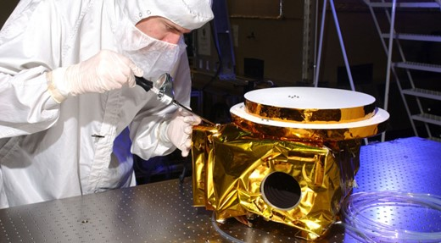
The Ralph imaging device Credit: Ball Aerospace & Technologies Corp.
Over the last week or so, images from the New Horizons mission have been arriving back at Earth as the probe begins the 16-month task of returning data from its July 14th Pluto flyby. Launched in January 2006, the craft traveled 2.97 billion miles to pass just 7750 miles from the surface of the dwarf planet that was only discovered in 1930. Scientists have been interested in Pluto because they believe its moons may have been formed in similar circumstances to those in which the Earth's moon was created, so the planet could hold clues to the history of our own planet.

The device acts more like a scanner than a single shot camera
Responsible for recording, among other things, the likeness of Pluto is the New Horizons camera module Ralph. Although widely compared to normal DSLRs the device acts more like a scanner than a single shot camera. Traveling at 31,000 miles per hour, the on-board imaging devices use the motion and rotation of the craft to scan the surface of the planet as it passes by. Ralph is responsible for producing the most impressive images via a process by which color and luminance data is combined from a collection of strips of CCD sensors.
A beam splitter is used to direct relevant wavelengths to the specific sensors designed to record them. The two focal planes, or bunched sensors, consist of a Multi-spectral Visible Imaging camera (MVIC) that 'sees' visible and near infrared light, and a Linear Etalon Imaging Spectral Array (LEISA) which is a short-wavelength, infrared, spectral imager.
A telescope with an effective focal length of 658mm and an aperture of F8.7 is used to collect the light that is then split according to wavelength and directed to either the LEISA or the MVIC.
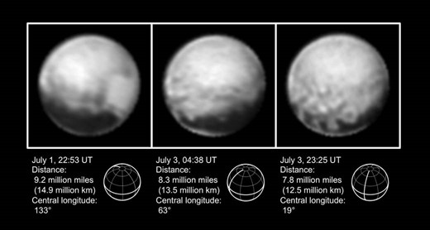
As the New Horizons craft gets closer to Pluto the resolution of the images returned increases and more detail of the planet's surface can be seen. Photo courtesy NASA
The MVIC uses 7 independent CCD arrays, six of which measure 5024x32 pixels. The CCDs operate in what is called TDI mode – Time Delay Integration. Similar to a scanner, the line of CCD pixels passes the object and gradually builds a picture from the information gathered over the time of the scan. Ralph uses 32 lines of pixels for each array so that light can be collected in an accumulative manner by each successive pixel that passes the same point.

Light levels on the surface to be photographed were very low –
about 1000x darker than daytime on Earth
Pluto was about 33 times farther from the sun than Earth is when New Horizons arrived, and Ralph had to photograph the dark side of the planet using light reflected from its moon Charon. Thus light levels on the surface to be photographed were very low – about 1000x darker than daytime on Earth or 400 times darker than the Mars probe had to work in. The 32 lines of pixels, passed in a 'push-broom' motion, are designed to produce high resolution images that display high signal-to-noise ratios, by increasing 32 times the duration of the 'exposure'.
Two of the sensor arrays in the MVIC are panchromatic, recording images in black and white, while the other four are fitted with filters to restrict them to 400-550nm (blue), 540-700nm (red), 780-975nm (near infrared) and 860-910nm (narrow band methane) so that they can add color and other information to the images captured by the panchromatic sensors. The methane sensitivity is designed to detect frost.
The seventh sensor-set of the MVIC part of Ralph is a 5024x128 array that is used simply to record where the craft is going for the optical navigation system.

In the highest resolution images from 'the Ralph instrument',
each pixel will record 70 meters of planet
Unlike a scanner, in which the array passes from one end of the subject to the other, Ralph will use the rotation of the craft to scan the surface of each segment of the planet. Rotation speeds were expected to be 1600 µrad/sec (micro radians per second) for the panchromatic sensors and 1000 µrad/sec for the color-sensitive CCDs, giving an integration time (exposure) of 0.4 and 0.6 seconds. As scientists know the rotation speed of the craft they synchronize the clocking of each pixel to allow the accurate build-up of data from any individual point across the 32 rows of CCD pixels. The imaging pixels in the MVIC measure 13x13µm², and in the highest resolution images from 'the Ralph instrument', as NASA refers to the camera, each pixel will record 70 meters of planet.
According to early calculations scientists predicted that a line of 4600 pixels would be required to create a 1km/line pair image across the 1429mile/2300km diameter of the planet. The remaining 400 pixels are used in the case of pointing inaccuracies and drift during the scan. It has been discovered that Pluto's diameter is 1473 miles.
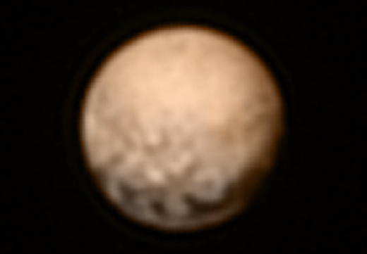
Pluto from New Horizons, July 8, 2015. This image of Pluto is from New Horizons' Long Range Reconnaissance Imager (LORRI), a black-and-white high resolution camera. The image was received on July 8, and has been combined with lower-resolution color information from the Ralph instrument. Photo courtesy NASA
Between the MVIC and LEISA modules Ralph will provide 3D images and mapping information of the planet and its moon Charon, as well as information that will help scientists determine what the two bodies are made from. As the craft flies away from the planet it will turn to record the view of the body with the sun behind it, and images from that stage of the mission are hoped to reveal evidence of atmospheric haze.
The craft has been recording Pluto for some time, using a long range imaging device, but the most detailed information will come once all the data from Ralph has arrived on Earth. The connection is pretty slow, with signals taking 4 hours and 25 minutes to pass between the craft and the control room. While recording Ralph can't transmit, so information is saved to solid state memory on board, and the stored data is expected to take the next 16 months to send home.

What we have seen so far is just the beginning
Ralph got some practice in on the way to Pluto as the craft passed Jupiter in 2007 and provided images of lightning near the planet's poles, the planet's volcanic moon lo and close-up views of the Jovian ring system. The pictures and data recorded delivered a mass of unknown information about the planet, its weather and its composition, and the same is expected of Ralph's images from Pluto and Charon. What we have seen so far is just the beginning.
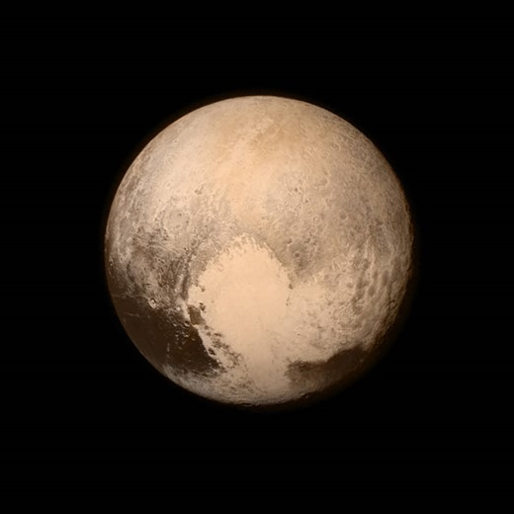
The latest image of Pluto from Ralph, combining a higher resolution image with color information from the filtered CCD arrays. Photo courtesy NASA
For more images see the NASA gallery for the New Horizons mission.

Spec sheet:
Mass: 10.5 Kg
Power: 7.1 Watt (maximum)
Telescope Aperture: 75 mm
Focal Length: 657.5 mm
f/#: 8.7
MVIC: Time Delay and Integrate (TDI) and framing arrays
2 Redundant 5024x32 Pixel Panchromatic TDI CCDs (400 – 975 nm)
Four 5024x32 Pixel Color TDI CCDs
Blue (400 – 550 nm)
Red (540 – 700 nm)
NIR (780 – 975 nm)
Methane (860 – 910 nm)
5024x128 Frame Transfer Pan CCD
13µm x 13µm pixels
Single pixel Field of View: 19.77µrad x 19.77µrad
TDI array FOV: 5.7degreesx0.037degrees
Framing camera FOV: 5.7degreesx0.146degrees
Focal plane temperature: <175 K
Pan TDI rate: 4 – 84 Hz
Color TDI rate: 4 – 54 Hz
Frame transfer integration time: 0.25 – 10 sec.
LEISA: 256x256 element HgCdTe array operated in pushbroom mode.
40µm x40µm pixels
Single pixel Field of View: 60.83µrad x 60.83µrad
FOV: 0.9degreesx0.9degrees
Focal plane temperature: <130 K
Frame rate: 0.25 – 8 Hz
Source: Southwest Research Institute

